Kool & the Gang – Ladies Night
YAM: wurli Z21 bank – 1. brass 2. claps 3. voice

Intro 16
Chorus 8
Verse 8
Chorus 8
Verse 8  4  4 | "Romantic lady..."  "If you hear any noise…"  "Gonna step out ladies night..."
Chorus 8
Bridge 8  8  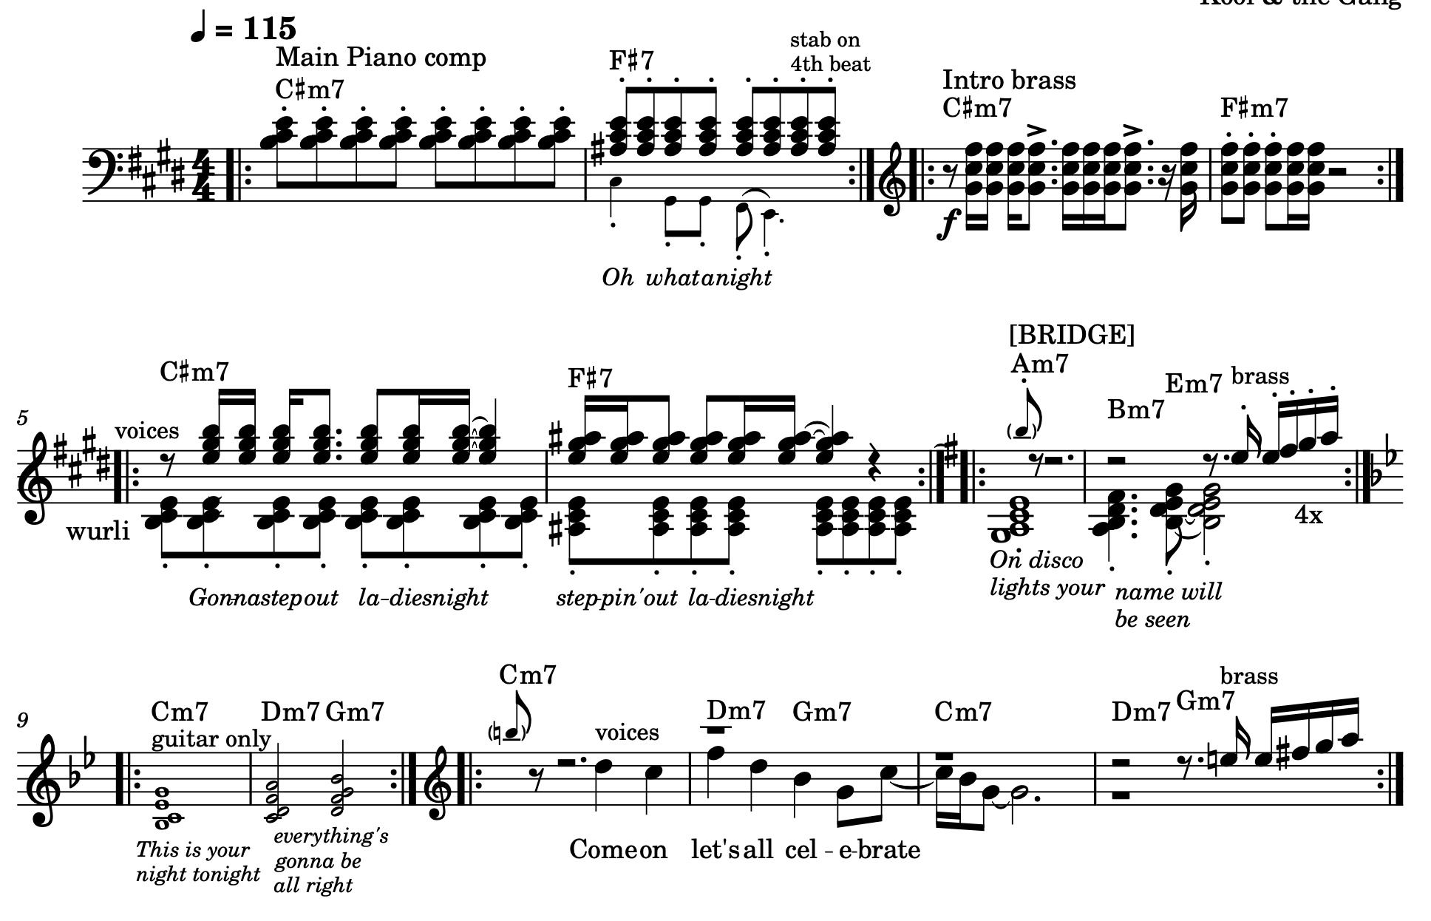  12 to fade | Am7: "On disco lights…"  cm7: "This is your night…"  "Come on let's all cel..."

